Purpose
The Identity Swapper module will allow you to change the identity of current user in your application. This should only be used during testing (manual and automated), to allow testing with different users/roles.

Version History
Date | Version | Author | Comments
7/22/2013 | 1.3 | Dusan Palider | Added the ability to try and auto-resolve the domain for the supplied NTID (if needed); Fixed the cookie update mechanism to actually update the cookie;
6/24/2013 | 1.2 | Dusan Palider | Renamed the module to IdentitySwapper to better communicate what the module actually does; Added additional restrictions with Active Directory groups, to restrict who can swap identities, to prevent possible data leaks
6/12/2013 | 1.1 | Dusan Palider | Added Appendix A – cookie removal instructions
6/12/2013 | 1.05 | Dusan Palider | Added username/roles validation information
6/11/2013 | 1.0 | Brian Williams | Added Coded UI Module information
6/11/2013 | 0.95 | Dusan Palider | Clarified Roles; Added step 7 into integration instructions; Added id information for automated tests; Cleaned up formatting a bit;
6/11/2013 | 0.9 | Dusan Palider | Initial Release

Newest Version
The newest version of this document can be found in TFS. Directions on how to get there are in the 1st step of Integration Instructions.

Questions/Comments
Please send your questions or comments to Dusan Palider - Dusan.Palider@lmco.com

Requirements/Assumptions
- the script portion of the module uses JS and cookies. There’s no specific library or version requirement.
- the .Net portion of the module uses .Net 3.5 version. If your application is using a lower version of .Net, please contact the author. This library requires an Active Directory server to verify that the user running the application is a member of a group that is allowed to swap identities
- the module will work if your application is using either Thread.CurrentPrincipal or HttpContext.Current.User to get the current user information. If you are using a different method for retrieving current user information, please contact the author to integrate it into the module.

Security/Restriction on Identity Swapping
- the identity swapping is driven by settings in web.config

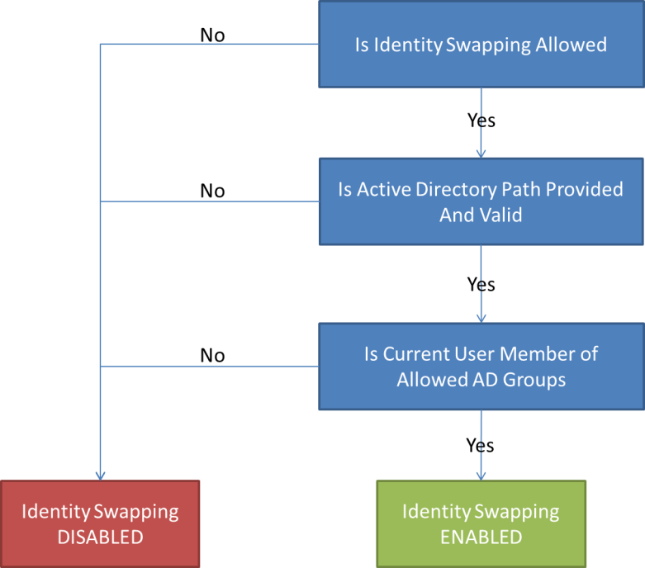

Integration Instructions
Constants used:
[SCRIPT_LOCATION] – location of the script file in your project

- Download the project from TFS and build it as a Release configuration.
- the build will copy all of the required files into the bin\Release folder
- TFS server information:
  - URL: absstfs2010.isgs.lmco.com\IT_Applications
  - Project Name: ProgramServicesSharedCode
  - Folder: Impersonation

- Add a reference to the Impersonation.dll into your project.
- copy the library into the location that you use to store external libraries

- Add the ImpersonationScript.js to your Scripts folder.

- Add web.config setting.
- into appSettings section of web.config file, add the following keys:
<add key="IsIdentitySwappingAllowed" value="true"/>
<add key="ActiveDirectoryPath" value="GC://us.lmco.com" />
  - unless you already have this in your application, in which case you can use existing values

<add key="ADGroupsAllowedToSwapIdentity" value="ipe.agile.testingaccounts" />
  - a comma separated list of AD groups allowed to swap identities; the group above contains all test accounts

- make sure you setup your build automation to turn identity swapping OFF for production environment. In order to disable the identity swapping in an environment, you can either remove this key/value pair altogether, or set its value to false (please see step 7).

- In all of your Site.Master or layout pages place the following div/script tag.
- this should be placed on top of the page (usually first thing in the body element)
- the inclusion of the script file will automatically display the identity swapping control on the page and so it should be conditional on you wanting for impersonation to happen. We recommend using the built in method IsIdentitySwappingAllowed which uses the web.config setting to decide whether identity swapping should happen.
- the following syntax can be used:
  - aspx syntax in MVC:
<% if (IdentitySwap.IdentitySwappingForTesting.IsIdentitySwappingAllowed("IsIdentitySwappingAllowed", "ActiveDirectoryPath", "ADGroupsAllowedToSwapIdentity")) { %>
<div id="IdentitySwappingDiv">
<script src="<%= this.ResolveClientUrl("[SCRIPT_LOCATION]")%>"type="text/javascript"></script>
</div>
<% } %>
  - razor syntax in MVC:
@{ if (IdentitySwap.IdentitySwappingForTesting.IsIdentitySwappingAllowed("IsIdentitySwappingAllowed", "ActiveDirectoryPath", "ADGroupsAllowedToSwapIdentity")) {
<div id="IdentitySwappingDiv">
<script src="@Url.Content("[SCRIPT_LOCATION]")" type="text/javascript"></script>
</div>
}
}

- Insert the call to the SwapIdentity method.
- we are recommending you do this in your base controller event handler for OnActionExecuting. Alternatively, you could make the call every time you request current user information (swap identities first, and then provide user information.
- the new identity only lasts for the duration of the request. The next request that the user makes reverts to the user’s identity. That’s why we have to swap the identities every time the user makes a request.

IdentitySwap.IdentitySwappingForTesting.SwapIdentity("IsIdentitySwappingAllowed", "ActiveDirectoryPath", "ADGroupsAllowedToSwapIdentity");

- Setup your build automation files to turn the web.config setting on and off, based on the target environment.
- to turn the identity swapping off, add the following transform:
<add key="IsIdentitySwappingAllowed" value="false" xdt:Transform="SetAttributes" xdt:Locator="Match(key)"/>
<add key="ADGroupsAllowedToSwapIdentity" value="" xdt:Transform="SetAttributes" xdt:Locator="Match(key)"/>

Usage Instructions

- When you start up the application, a new banner should be displayed if the identity swapping is active.

- Enter in the information and click Swap Identities:
- UserId should contain the domain. For example acct04\paliderd
- Roles are optional, and should only be used if your application is using either of the following methods to decide if your user belongs to a role: Thread.CurrentPrincipal.IsInRole(); or HttpContext.Current.User.IsInRole();
If you do use either of these methods, then you can enter in your desired roles as a comma separated list (please note that this may also include AD groups, if you use those in your application). For example: Admin, CaptureReader. In a situation when your application uses a database table for roles, and you do not store them in the Principal object, you can leave this field blank.
  - Validation
- UserId can only contain letters, numbers, underscore, backslash and dash
- Roles can only contain letters, numbers, underscore, backslash, period, comma, space and dash

- Once you click Swap Identities, the banner will change, displaying the information about the new identity.
- this will also reload the page to make the new identity take effect
- the cookie that sets the new identity lasts for 30 minutes, and each requests restarts the clock

- When you are finished, or if you want to switch users, click Clear Identity Swapping.
- this will clear out the new identity and reload the page
- the green banner should be displayed again, allowing you to swap identities again

- Clearing the cookie manually
- if the cookie ever gets corrupted, you have 2 options:
  - wait 30 minutes, after that time the cookie expires
  - clear out the cookie manually (please see Appendix A)

Coded UI tests
- ids of the objects involved:
- id of the UserId field is: impersonationUserName
- id of the Roles field is: impersonationRoles
- id of the Impersonate button is: impersonationImpersonateButton
- id of the Clear Impersonation button is: impersonationClearButton

- for Coded UI tests, a UI page to interact with the impersonation module is checked in at the following location:
ProgramServicesSharedCode\CodedUITestsCommon\Common\Pages\ImpersonationBanner.cs

- to include this functionality in your UI tests, compile the CodedUITestsCommon\Common.csproj file and add a reference to ProgramServices.UITests.Common.DLL to your Web Test project.
- impersonationBanner uses CSS selectors from ProgramServicesSharedCode to find and interact with the impersonation UI elements. Methods are available to set the User Name and Role inputs to given values, and to click the Impersonate and Clear buttons.

Appendix A: Manual Cookie Removal
  - IE 8:
- open IE, then navigate to Tools -> Internet Options -> Browsing History Settings

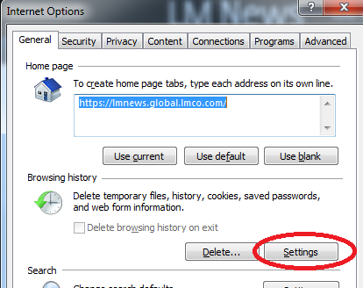

- click View Files
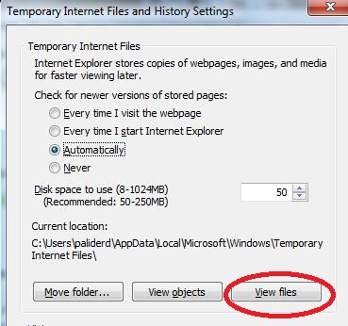

- this will open up a folder where your temporary files are. Make sure that you can see hidden files.
- find a file that is named cookie:[YOUR_NTID]@[YOUR_APP_URL].txt

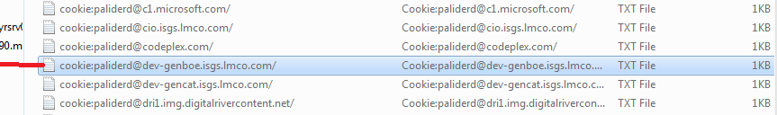

- if you want to double check, open that file in notepad and you can see that it has a section w/ the impersonation information
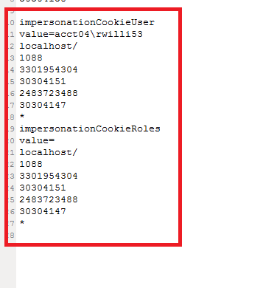
- delete the file, thus manually clearing out the cookie

  - Firefox:
- open FF, then navigate to Tools -> Options -> Privacy and click on remove individual cookies

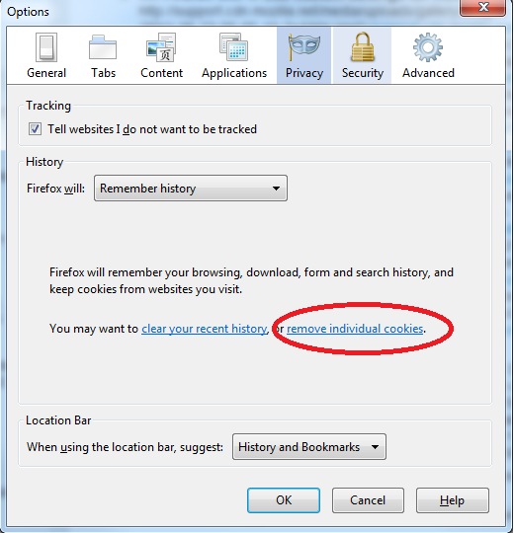

- find the URL of your website, and remove the cookie named “impersonationCookie”
